Case Study 7 Snippets

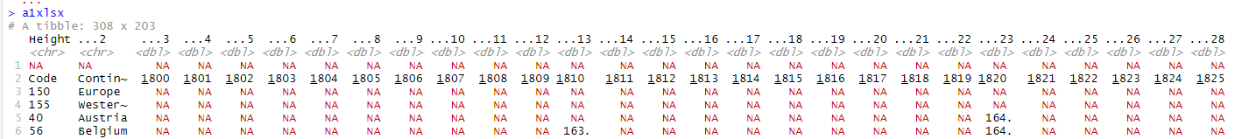Tubingen

Skip = 1

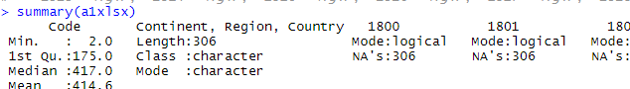

German Conscripts

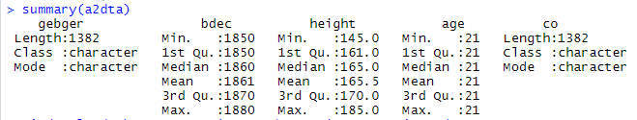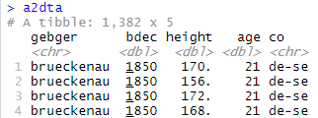

German Prisoners / Bavarian Conscripts

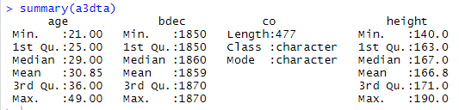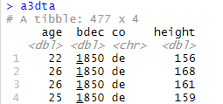

SESW Soldiers

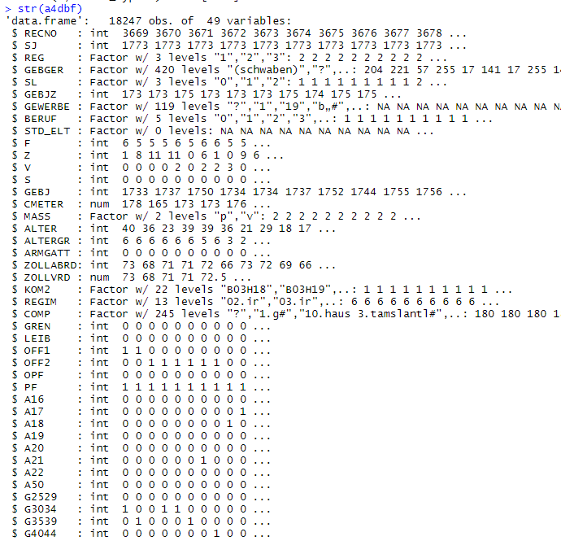

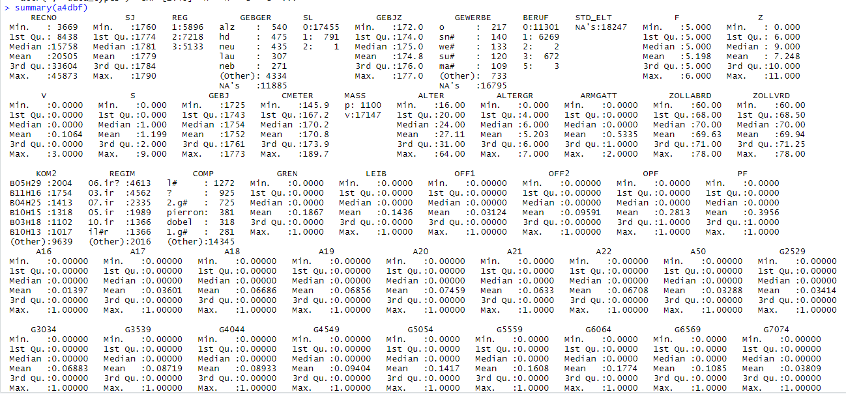

BLS csv

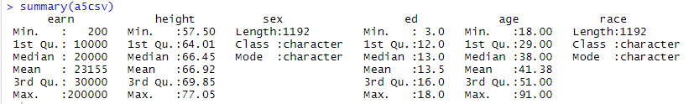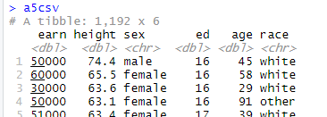

Wisconsin Survey



